CardKeep Package Overview
Version 0.6.2 · October 2026 · github.com/AxialForge/cardkeep
This overview explains CardKeep three times, each in more depth: a short version for anyone, a medium version for
people deciding whether to use it, and an advanced version for developers and reviewers.

Part 1: The simple version
What it is. CardKeep is a phone app that turns paper business cards into contacts.
What it's for. You collect cards at meetings and trade shows. They pile up in a drawer and the people on them are
hard to find later. With CardKeep you take a photo of each card; the app reads the name, job, company, phone numbers
and email, and saves them as a contact with the card attached. Later you can search for anyone, call them, set a
reminder to follow up, and see who you met at which event.
How it works. Everything happens on your phone. The app reads the card itself instead of sending the picture to a
website, and your contacts are never uploaded anywhere. There is no account to create. The only time it uses the
internet is to check for a newer version, and only when you ask.
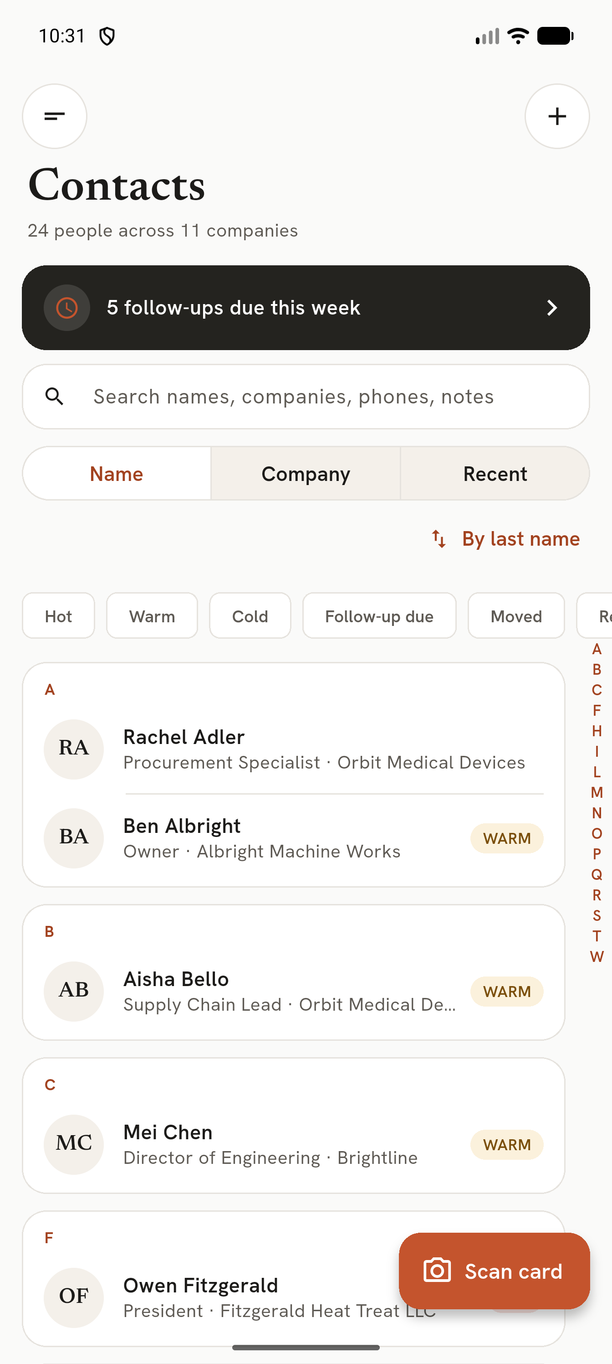
Contacts

Part 2: The medium version

What it does
Area | What you get
Scanning | Live card outline, hints, automatic capture; one card, a batch, or a pile in one photo; gallery photos; back sides; QR codes
Reading | On-device text recognition, fields filled in, unsure fields marked; tap-to-fix and read-a-region
Contacts | Search across every field, filters, A–Z index, lead ratings, notes, tags, the card itself
Follow-ups | Due dates, reminders on the day, drafted follow-up emails
Events | Trade shows as scan sessions, goals, "met at", follow up with everyone
Duplicates and careers | Possible duplicates with reasons and a merge screen; job changes and retirements tracked
NFC and My card | Read NFC business cards; share your own details as a QR code or contact file
Data in and out | vCard and CSV import/export (Google, Outlook, HubSpot, Salesforce, LinkedIn), full backup zip and restore

Who it's for
People who meet many others in person: sales, purchasing, engineers at suppliers and customers, anyone working trade
shows. It suits someone who wants their network on their own phone rather than in a company CRM or a cloud service.

Privacy in practice
- No account, no analytics, no ads. Google's ML Kit telemetry is switched off.
- Data lives in the app's private storage, excluded from Android cloud backup and device transfer.
- Deleted contacts are wiped after 7 days. Photos are saved without location data.
- The app goes online only for update checks, and verifies downloads against GitHub's checksums.

Limits today
Android only. Installed from GitHub, not Google Play. No app lock, no sync with a computer, and the on-phone database
is not encrypted (it relies on Android's app sandbox). These are on the roadmap.

Part 3: The advanced version

Stack
Layer | Choice
UI | Flutter 3.47 (Dart 3), Material with custom themes, go_router, Riverpod 3
Storage | SQLite via drift 2.35 (schema v3, migrations from v1), files in app-private storage
Text recognition | Google ML Kit Text Recognition (bundled Latin model, on device)
Barcodes | ML Kit Barcode Scanning (QR: vCard, MECARD, URLs)
Image processing | OpenCV (opencv_dart / dartcv4, built from source) for card detection and perspective correction; image package for encoding
Camera | camera plugin (CameraX on Android)
NFC | nfc_manager 4 + NDEF records
Reminders | flutter_local_notifications 22.3 with inexact alarms and boot receivers
Phone numbers | phone_numbers_parser (region-aware validation and formatting)

Code map
Folder | Holds
lib/app | App shell, router, theme, drawer, providers, start-up jobs (restore result, recovery, purge, backup)
lib/scan | Scan pipeline and background worker
lib/parser | Turns OCR lines into fields (rules, confidence, casing, QR merge)
lib/core/db | drift schema, migrations
lib/core/* | Repositories: contacts, cards queue, career, duplicates, events, follow-ups, tags, images, transfer (vCard/CSV/backup), update, links, settings
lib/features/* | Screens per area
lib/nfc | NFC reading

Scan pipeline
- Capture (camera or gallery). The JPEG is written to cards/pending/ *before* any processing, so a kill never
loses a capture; the camera's own temp file is deleted.
- Detect the card quadrilateral with OpenCV (edges, contours, corner ordering). Live hints come from the same
detector at low resolution: size, sharpness (Laplacian variance), steadiness across frames, glare and exposure.
- Rectify: perspective-correct to at least 1400 px on the long side; dark cards get a contrast-boosted second pass.
- Read: ML Kit text recognition plus barcode scan on the rectified image.
- Parse: rule-based field extraction (names, titles, companies, phones with extensions and fax, emails, URLs,
addresses, extras), input capped at 200 characters per line and 80 lines per side to keep regexes linear. Each field
gets a confidence from the OCR confidence, the rule that matched and cross-checks; a contact QR overrides text.
- Queue: the card row is committed to the review queue; only then is the pending file removed. Clear cards in Batch
and Pile can be saved straight to contacts. A capture that fails three times moves to cards/pending/failed/.
Images are content-addressed (SHA-256) under cards/original, rectified, thumb and logo, with EXIF stripped.

Data model and lifecycle
People, contact points, roles (person ↔ company with dates and status), companies, cards, tags, events, follow-ups,
change suggestions, successions and a full-text search table. Times are stored as Unix seconds. Delete is a tombstone
(deleted_at) for undo and future sync; after 7 days a purge blanks the person row, deletes their details, cards and
search entry, and removes image files nothing references.

Backup format
One zip: card_organizer.sqlite (a consistent VACUUM INTO copy with deleted people purged), the referenced card
images, and manifest.json (app, version, schema, created, counts, SHA-256 per file). Restore checks the manifest,
every hash, size limits (1 GB zip, 2 GB unpacked), rejects unlisted files and path escapes, and runs
PRAGMA integrity_check on the staged database. The swap happens at the next start, before the database opens, as a
journalled sequence (old → new → keep → done) that resumes after a kill and never deletes the only copy of
anything; the previous data is kept in before_restore/ for 30 days.

Network and trust
The only network code is the updater: it reads the latest GitHub release, requires the asset's SHA-256 digest, caps the
download at 200 MB, verifies the hash and hands the APK to Android's package installer. ML Kit's transport backend
registration is removed from the merged manifest, so its telemetry has no destination. allowBackup=false with
data-extraction rules excluding everything. Incoming vCard intents are accepted only from content:// URIs outside the
app's own providers. Clipboard copies of contact details are marked sensitive; debugPrint is silent in release.

Build and release
R8 shrinking with keep rules for ML Kit. Release signing requires key.properties (no debug-key fallback); v2 + v3
signatures. CI (GitHub Actions, actions pinned to commit SHAs) runs analyze and tests on every push; a vX.Y.Z tag
builds split APKs and publishes them with SHA256SUMS.txt, the R8 mapping and Dart debug symbols.

Quality
180 automated tests (unit, widget and data-layer), including a simulated kill at every step of a restore, schema
upgrade v1 → v3, hostile-input timing tests for the CSV and OCR parsers, and a ground-truth set of real card OCR. A
structured mobile release audit (OWASP MASVS-mapped) verified 34 fixes for 0.6.2: the GitHub channel is a Conditional
Go; Google Play is pending (Play build without the updater, AAB, privacy policy, Data safety form).

